Cody Competition Guide

This guide will give you an overview of how to run a Cody competition. Read through this entire document before you move on to other files in this folder.

# Overview

A Cody competition is a 2-week event in which students compete to solve the most MATLAB problems in a problem group. The problems in these groups are chosen to engage students with various MATLAB experiences. Participants are ranked on a leaderboard based on the number of problems they solve correctly as well as the efficiency of their code.

# Leaderboard

A guide on setting up the leaderboard can be found in the file titled ‘2_Leaderboard Instructions.docx.’ As an overview, the code for the leaderboard is set up to do 3 main things:

1. **Find users at your university who participate in this competition**. The code will find the players by their school domain. Because of this, for students to participate they must use their school email address. If their MathWorks account isn’t registered to their school email, they won’t appear on the leaderboard and therefore ineligible for the competition.
2. **Rank players based on number of problems solved then on solution size**. To avoid ties in participants who solve the same number of problems the total solution size across.
3. **Output a leaderboard file**. Your job will be to update the participants of the rankings. To keep the participants engaged and competing against each other, post the leaderboard every couple of days.

# How to Participate

The competition should be advertised to all students on your campus. To participate, they simply use the link to the problem group and start solving problems. Participants must solve the problems while in the problem group. If they leave the problem group and solve a problem, it will not count towards their score. When you are solving problems for the group you will see the group problems on the right of the page (picture below).

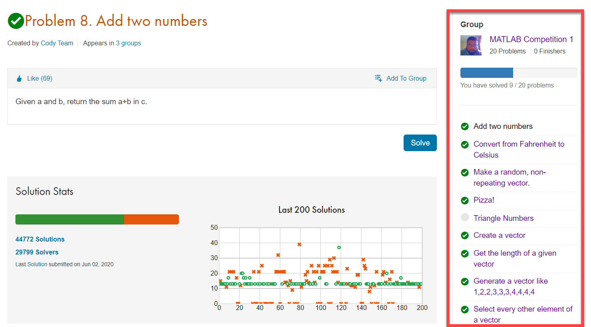

Problems must also be solved within the timeline of the competition. While their account may show that they solved the problem, the leaderboard code only counts solutions submitted during the specified start and end date of the competition.

## Disqualifying Participants

While it’s not likely to happen during your competition it is important to know that one can bypass the solution algorithm of Cody. If this does happen, the participant will be ineligible for any prizes. Only check winners at the end of the competition to see if there is any cheating.

Here is an example of how someone might bypass the system.

function ans = makeRandomOrdering(n)

! echo "function assert(~) " >./assert.m

end

We want the competition to be fun and stress free so try not to worry too much about this aspect. If you do have any questions about whether you should make someone ineligible for prizes, feel free to reach out to Roshan Hingnekar.

# Timeline

|  |  |  |
| --- | --- | --- |
| When | Description | Actions |
| 4 weeks before | Start planning the logistics for the competition. | * Decide dates for competition |
| 3 weeks before | Test the leaderboard code to ensure it’s working for your university domain. | * Test setting up the leaderboard code * Solve a few problems and see how it appears on the leaderboard |
| 2 weeks before | Begin advertising! To increase the number of participants, advertise early and advertise to everyone. | * Share the competition dates * Inform professors about this competition |
| 1 week before | Set up leaderboard | * Use 2_Leaderboard Instructions.docx to set up leaderboard |
| During | Share the leaderboard with your social media group every couple of days. Encourage people to keep participating | * Post Leaderboard frequently (both png and gif) * Continue promoting competitions * Encourage students to keep solving problems |
| Last day of competition | Once the competition ends, no more entries will be considered. Use the leaderboard to decide winners. | * Announce the winners and thank everyone for participating |
| 1 Week after | Set up time to give out prizes. It’s suggested that you set up time slots on 2 different days. | * Hand out prizes |

# Promoting the Competition

As with all events, the key to having a successful turnout is to promote early and promote to as many places possible. Unlike other events however, there are no barriers to participate in this competition. Because of this, it is imperative that you promote to as many different groups on campus as possible. The following files are included in the folder to help you promote the competition.

* **3_Poster Sample.pptx** – A poster explaining the competition
* **4_Email Template.docx** – An email invite explaining the competition and how to participate
* **5_Reminder_Email Template.docx** – An email reminding student that the competition is going on and the current rankings
* **6_Social media flyer.pptx** – Smaller banner image intended to generate interest for the competition on social media

# Problem Groups

For the competition use one of the following problem groups. Each group is private and therefore can only be accessed through the link.

|  |  |  |  |
| --- | --- | --- | --- |
| Problem Group | Description | Topics | Group ID |
| [MATLAB Competition 1](https://www.mathworks.com/matlabcentral/cody/groups/2808) | Covers the basics of MATLAB and some questions at the end to test your skills. | MATLAB basics, vectors, matrices, indexing, strings, computational geometry | 2808 |

# Prizes

To keep students motivated to win this competition we recommend that you give prizes to the winners. It is up to you, however, to consider if/what prizes should be given for your competition. Be sure to consider whether you can logistically give out giveaways, the number of participants, and what giveaways you currently have.